Lab Task # 01 (Schema Definition):
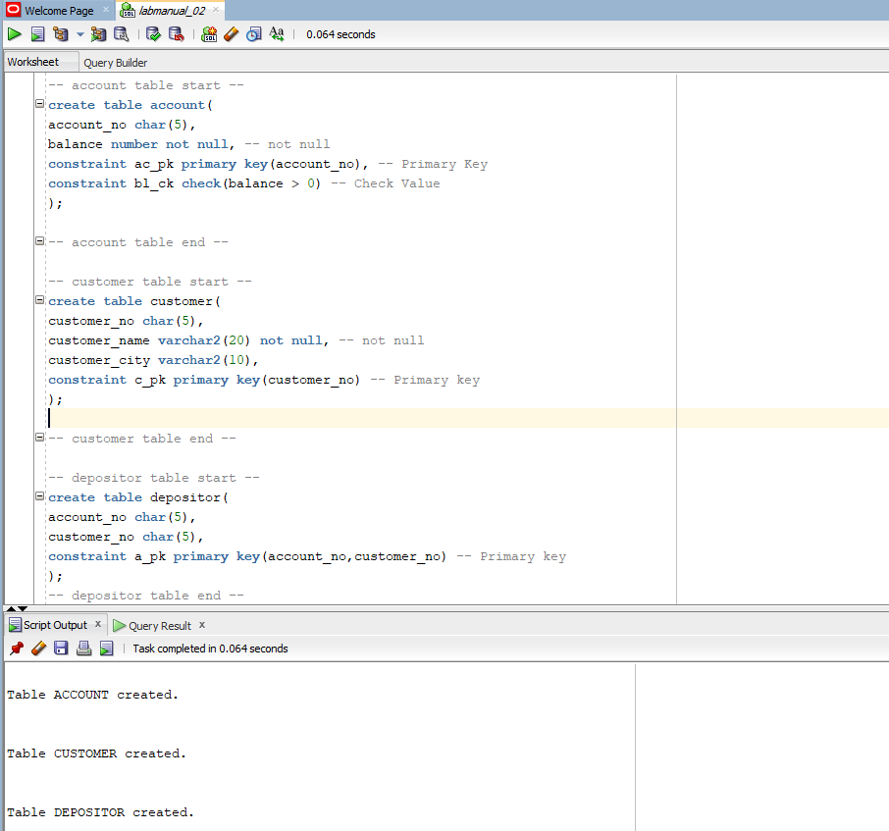

Lab Task # 02 (Schema Modification):
- Write SQL statement to add a new attribute ‘date_of_birth’ (date type) in customer table.
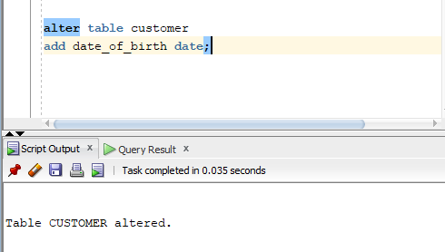
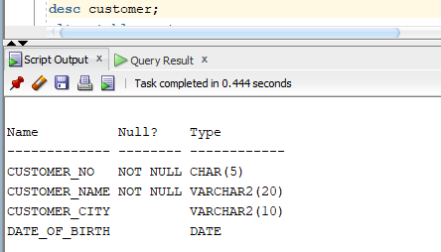
- Write SQL statement to drop the attribute ‘date_of_birth’ from customer table.
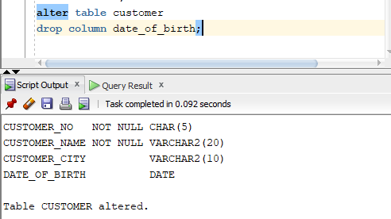
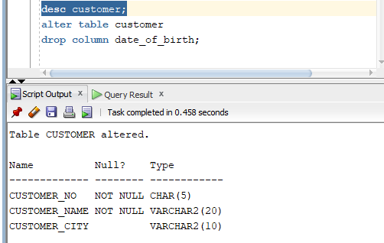
- Write SQL statement to rename the attribute account_no, customer_no from depositor table to a_no and c_no, respectively.

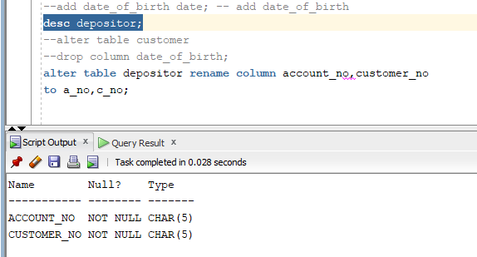
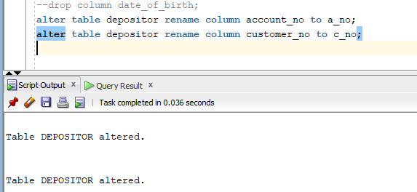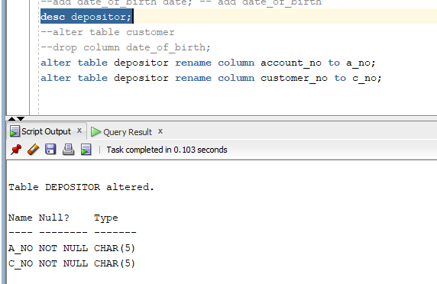

- Write SQL statements to add two foreign key constraints ‘depositor_fk1’ and ‘depositor_fk2’ which identifies a_no and c_no as a foreign key.
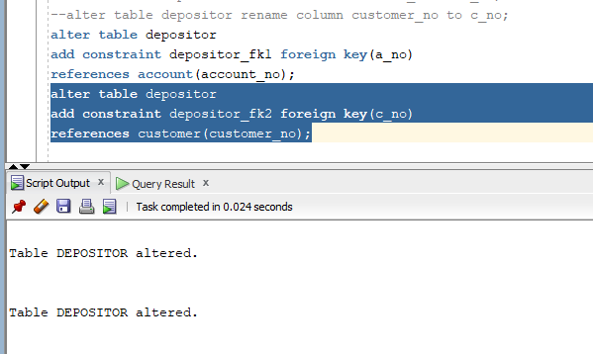
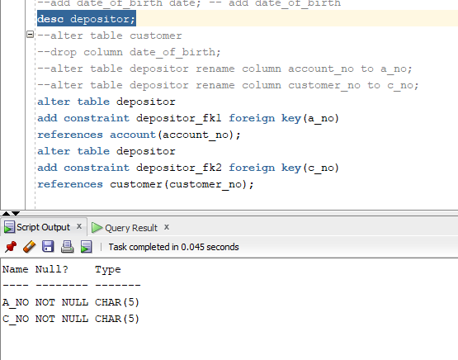

Lab Task # 03 (Inserting Records into Tables): 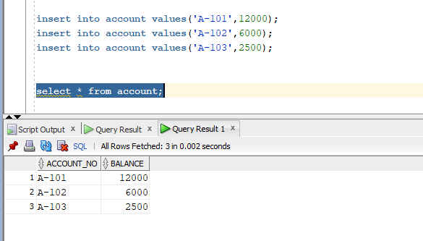
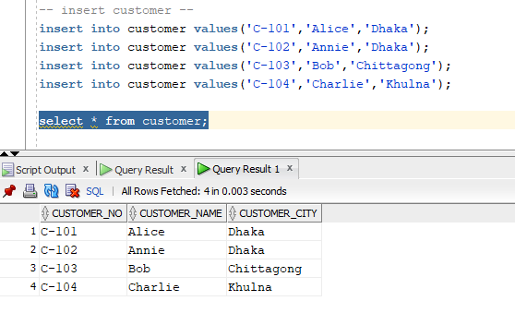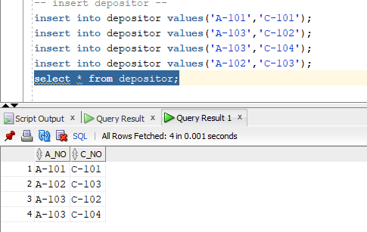
Lab Task # 04 (Queries):

- Display customer name and customer city only.
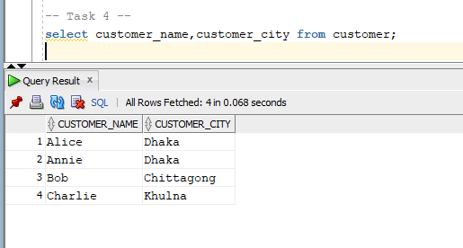
- Display the unique customer city. No repetitions are allowed.
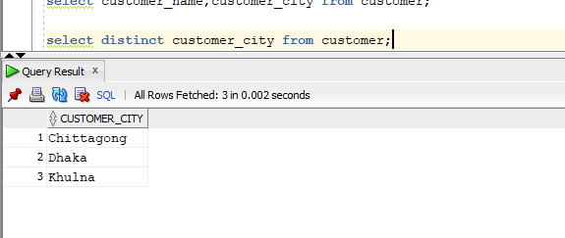
- Find account numbers with balance more than 7000.
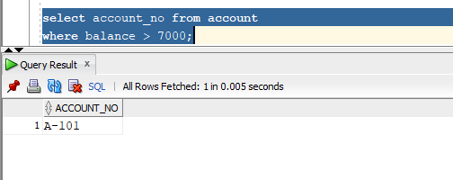

- Find customer number and customer name who live in Khulna.
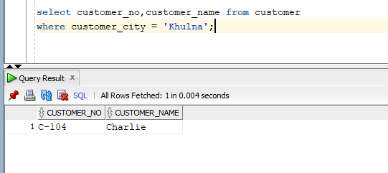
- Find customer number and customer name who do not live in Dhaka.
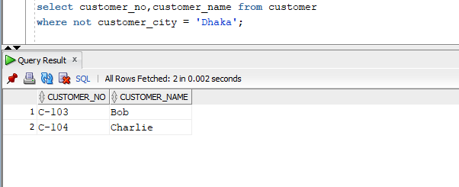
- Find customer name and customer city who have accounts with balance more than 7000.
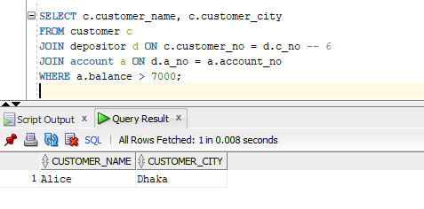
- Find customer name and customer city who have accounts with balance more than 7000 and do not live in Khulna.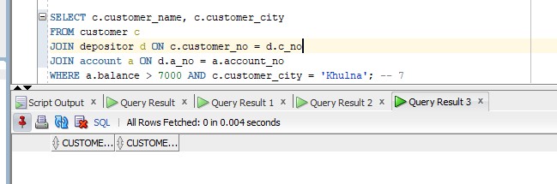
- Find account number and balance for those accounts which belong to a customer with id ‘C-102’.
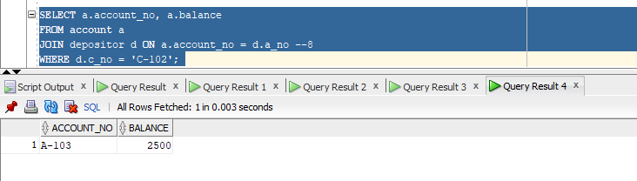
- Find all account number and balance for those accounts which belong to customers of Dhaka and Khulna city.
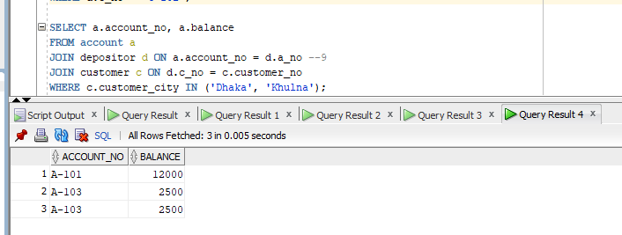

- Find the customer who have no accounts.
